[Leaders](https://www.economist.com/leaders/) | Demography

Large parts of Asia are getting old before they get rich

## Even poor countries must start planning for an ageing population

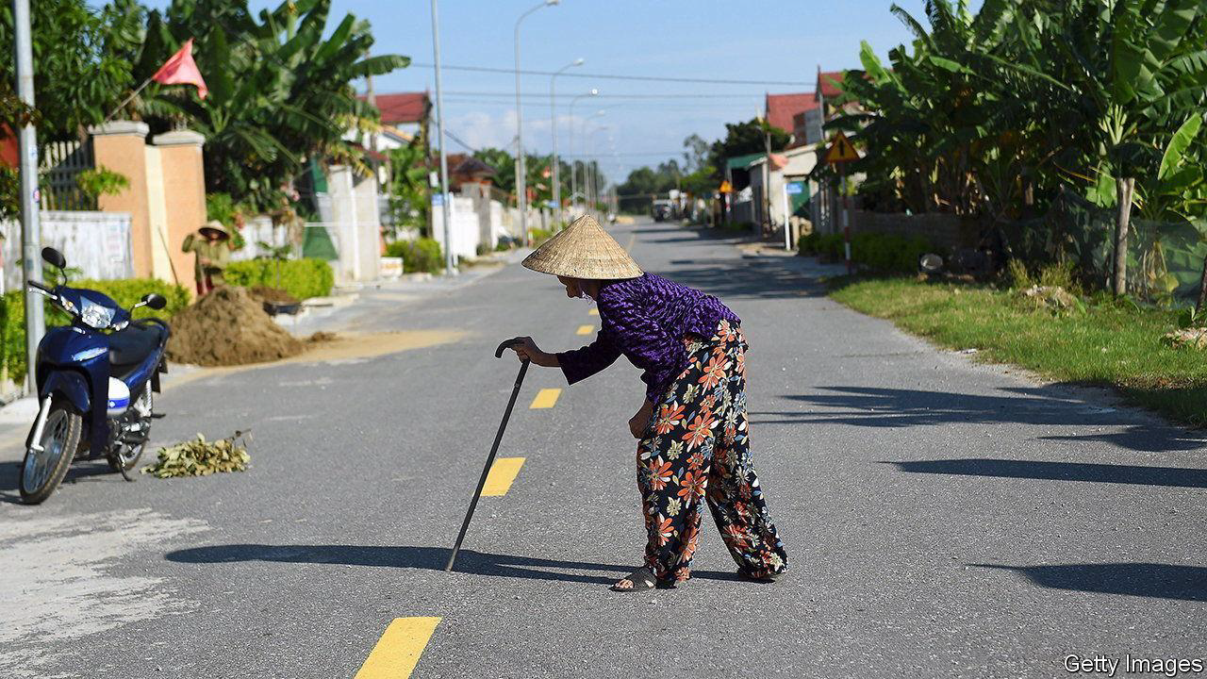

image: getty images

Abulge in a country’s working-age population is a blessing. Lots of workers support relatively few children and retired people. So long as the labour market can absorb a surge of job-seekers, output per head will rise. That can boost savings and investment, leading to higher economic growth, more productivity gains and developmental lift-off. Yet for countries that fail to seize this opportunity, the results can be grim—as many developing countries may soon discover.

一个国家的劳动年龄激增是一种福音。许多工人支持相对较少的儿童和退休人员。只要劳动力市场能够吸纳大量求职者，人均产出就会增加。这可以促进储蓄和投资，从而使经济增长更快、生产率提升和发展起飞。然而对于未抓住这一机遇的国家来说，结果可能是严峻的-正如许多发展中国家可能很快会发现的那样。

Consider Thailand. It is rapidly greying. In 2021 the share of Thais aged 65 or over hit 14%, a threshold that is often used to define an aged society. Soon Thailand will, like Japan, South Korea and most Western countries, see a dwindling supply of workers and, without extraordinary measures, flagging productivity and growth. Yet unlike Japan and the rest, Thailand, with a gdp per person of just $7,000 in 2021, is not a developed country. It has got old before it has got rich. When Japan had a similar portion of oldies, it was roughly five times richer than Thailand is today.

以泰国为例。它正在迅速变灰。 2021年，泰国65岁或以上的人口比例将达到14%，这个门槛经常被用来定义老龄化社会。很快，泰国将像日本、韩国和大多数西方国家一样，看到劳动力供应减少，如果不采取特别措施，生产力和经济增长也会下降。然而，与日本和其他国家不同的是，泰国2021年的人均国内生产总值仅为7,000美元，并不是一个发达国家。未富先老。当日本拥有类似比例的老龄化时，其财富大约是今天泰国的五倍。

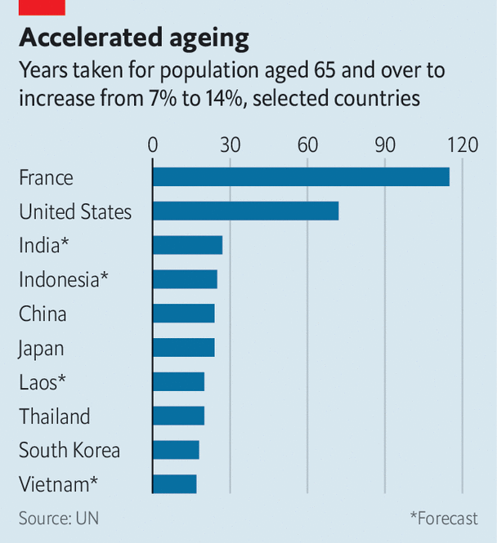

image: the economist

This is a big obstacle to Thailand’s future development. To protect its ageing citizens, many of whom are poor, Thailand’s government will have to spend more on health care and pensions. This will make it harder to invest in productivity-boosting skills and infrastructure. And where Thailand goes, many developing countries will follow. In Asia, where the problem is most advanced, Indonesia and the Philippines are also likely to become aged societies at lower income levels than was the case in the rich world. Sri Lanka, where the average income is a third lower than Thailand’s, will become aged by 2028.

这是泰国未来发展的一大障碍。为了保护老龄化公民（其中许多人很贫困），泰国政府将不得不在医疗保健和养老金方面投入更多资金。这将使投资于提高生产力的技能和基础设施变得更加困难。泰国走到哪里，许多发展中国家就会跟随到哪里。在这一问题最为严重的亚洲，印度尼西亚和菲律宾也有可能成为老龄化社会，其收入水平也低于富裕国家。斯里兰卡的平均收入比泰国低三分之一，到 2028 年将出现老龄化。

Countries that age before growing rich have failed to seize their demographic opportunity, or aged out of it too rapidly, or suffered both problems. Between 1960 and 1996 (just before the Asian financial crisis), Thailand’s economy grew at an average annual rate of 7.5%. That was impressive, but below Japan’s double-digit clip in its boom years. Meanwhile, thanks to improving life expectancy and other factors, Thailand has aged fast. The share of oldsters in its population doubled, from 7% to 14%, in two decades. It took Japan 24 years to undergo the same change, America 72, and much of western Europe over a century.

未富先老的国家要么未能抓住人口机会，要么过快地摆脱人口机会，要么同时面临这两个问题。1960年至1996年（亚洲金融危机之前），泰国经济年均增长率为7.5%。这令人印象深刻，但低于日本繁荣时期的两位数增长率。与此同时，由于预期寿命提高等因素，泰国老龄化速度加快。二十年来，老年人在人口中所占的比例翻了一番，从 7% 增至 14%。日本用了 24 年才经历了同样的变化，美国用了 72 年，西欧大部分地区用了一个多世纪。

Rapid ageing and slower growth are widespread in the developing world. Vietnamese are about half as rich as Thais and ageing even faster. India’s economy has been one of the world’s fastest-growing, yet not as fast as Thailand’s during its boom. In the decade to 2020 India grew at an average annual rate of 6.6%.

快速老龄化和经济缓慢增长在发展中国家普遍存在。越南人的富裕程度约为泰国人的一半，而且老龄化速度更快。印度经济一直是世界上增长最快的国家之一，但在繁荣时期却没有泰国那么快。截至 2020 年的十年间，印度经济年均增长率为 6.6%。

One conclusion is that countries with a working-age bulge need to wring more growth out of it. India may never have a better chance than the present. Under Narendra Modi it has a strong, pro-business government, which is likely to win re-election next year. There is a consensus on the measures, including privatisation and looser foreign-investment rules, that could raise its growth rate. Such reforms would help India take advantage of Western efforts to shift supply chains out of China. If India needs a cautionary tale to justify action, it need look no further than its own rapidly ageing southern states. In Kerala 17% of the population is 60 or older.

一个结论是，人口工作年龄激增的国家需要从中获取更多经济增长。印度可能永远不会有比现在更好的机会。在纳伦德拉·莫迪的领导下，它拥有一个强大的、亲商的政府，该政府很可能在明年赢得连任。人们对可能提高增长率的措施达成了共识，包括私有化和放宽外国投资规则。此类改革将帮助印度利用西方将供应链迁出中国的努力。如果印度需要一个警示故事来证明行动的合理性，那么它只需看看自己迅速老龄化的南部各邦就可以了。在喀拉拉邦，17% 的人口年龄在 60 岁或以上。

Another conclusion is that developing countries need to start planning for old age earlier. They should reform their pension systems, including by raising retirement ages. They should nurture financial markets, providing options for long-term saving and health insurance. They should create conditions for well-regulated private social care. And they should try harder to increase female participation in the labour force; in India it is a wretched 24%, half the global average. Getting more women into jobs would extend the demographic dividend and help deal with the fact that women live longer than men, but tend to have more meagre savings and pensions, and so are vulnerable in old age.

另一个结论是，发展中国家需要更早开始规划养老。他们应该改革养老金制度，包括提高退休年龄。他们应该培育金融市场，提供长期储蓄和健康保险的选择。他们应该为监管良好的私人社会护理创造条件。他们应该更加努力地提高女性劳动力参与率；印度的这一比例仅为 24%，仅为全球平均水平的一半。让更多女性就业将扩大人口红利，并有助于解决女性比男性寿命更长的问题，但她们的储蓄和养老金往往更微薄，因此在老年时更容易受到伤害。

Finally, developing countries should learn from the errors of rich ones by taking a pragmatic view of immigration. Hard as this can be politically, it is often the easiest way to extend the transition. Building sites in Bangkok already throng with illegal Burmese immigrants. By formalising them, Thai politicians could usher them into more productive roles.

最后，发展中国家应该从富国的错误中吸取教训，以务实的态度对待移民。尽管这在政治上可能很困难，但它通常是延长过渡的最简单方法。曼谷的建筑工地已经挤满了缅甸非法移民。通过将它们正式化，泰国政界人士可以引导他们发挥更有成效的作用。

**Dividend booster**

India provides a happier example of this. A continent-size country, its boom is fuelled by internal migration. Its last census, in 2011, counted 450m internal migrants. Many travel from the poor north to the more prosperous south and west, to seize new opportunities and, increasingly, to take up those being vacated by the south’s ageing workers. It is an inspiring illustration of what relatively unfettered labour markets can do—and a lesson for Japan, Thailand and governments everywhere. ■

印度提供了一个更令人高兴的例子。作为一个幅员辽阔的国家，其繁荣是由内部移民推动的。 2011 年的上次人口普查显示国内移民人数为 4.5 亿。许多人从贫穷的北方前往更繁荣的南方和西部，以抓住新的机会，并越来越多地接替南方老龄工人空出的机会。这是一个鼓舞人心的例证，说明了相对不受约束的劳动力市场可以发挥什么作用，也为日本、泰国和世界各地的政府提供了一个教训。

This article appeared in the Leaders section of the print edition under the headline "Prematurely grey"